Exposys Data Labs

Certificate of Internship

**TO WHOM IT MAY CONCERN**

This is to certify that **Mr. Avinash V** has completed internship programme on “**Data Science Analyst”** from 10.11.2021 to 10.01.2022.

He took keen interest in the work assigned and successfully completed it. During the period of internship, we found him to be punctual, hardworking and inquisitive.

We wish him luck and success in all his future endeavors.



**Y Vishnuvardhan**

Chief Director

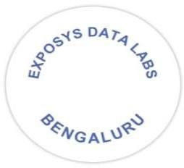[hr@exposysdata.com](mailto:hr@exposysdata.com) [www.exposysdata.com](http://www.exposysdata.com/)